Climbing Mt. StayQuit
Think About Quitting Smoking as an Attempt to Climb a Mountain

Some smokers are able to climb Mt. StayQuit quickly via Trail B. For others, this climb as shown in the diagram below via Trail A may take time.
.

- Adopt a realistic long-term perspective on changing.  - Although some people stop smoking the first time the try, for others it is a slower process.  - Yes, smoking cessation is hard, but IT IS POSSIBLE!  - If you should have a setback this does not mean you have not succeeded. You can use it as a learning experience and continue up the mountain.  IMPORTANT THINGS TO KEEP IN MIND WHEN YOU QUIT  - Review the benefits of quitting.  - Think of the negatives of returning to smoking  - Avoid smoking situations or triggers  - Learn alternative ways of managing high-risk smoking situations  - You are breaking old habits and developing new ones.  - Picture yourself as a nonsmoker. | 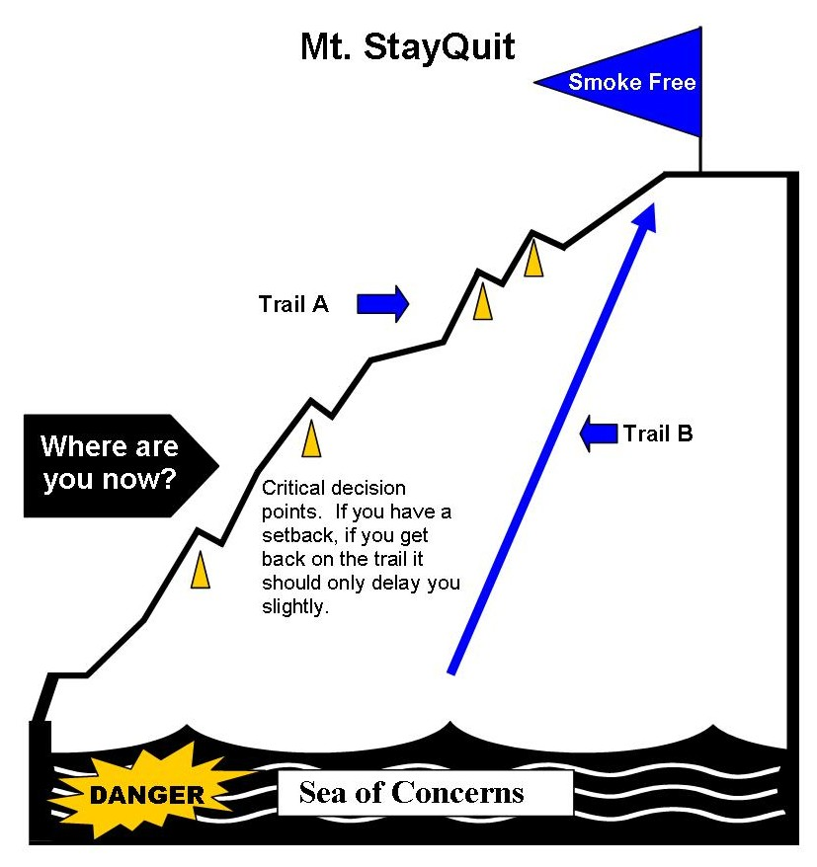

RESEARCH TELLS US THAT THE FOLLOWING ARE THREE

MAJOR REASONS WHY PEOPLE RELAPSE

- Missed having hands busy or missed holding something, most notably when drinking alcoholic beverages.
- Missed the feeling associated with smoking.
- Felt uncomfortable with smokers.

REWARD YOURSELF

- Think of ways to reward yourself as you climb Mt. StayQuit.
- Small rewards are a good way to celebrate your progress and to keep you focused on your ultimate goal: Quitting for Good!
- Use the space below to write your ideas.

Each week without smoking
______________________________________________________________________________

Each month without smoking
______________________________________________________________________________

Every 3 months without smoking ______________________________________________________________________________

Every 6 months without smoking ______________________________________________________________________________

Every year without smoking ______________________________________________________________________________

